Software Requirements Specification (SRS)

Table of Contents
1. Introduction 4
1.1. Purpose 4
1.2. Scope 4
2. Overall Description 4
3. Functional Requirements 5
4. Non-Functional Requirements 5
5. System Interfaces and Communications 6
6. Use Cases 7
UC-01: User Account Registration 7
UC-02: User Authentication and Login 7
UC-03: Search Parking Locations 7
UC-04: Reserve Parking Space 8
UC-05: Process Digital Payment 8
UC-06: Navigation Assistance to Garage 8
UC-07: Garage Entry Verification 8
UC-08: Extend Parking Session 9
UC-09: Garage Exit Verification 9
UC-10: View Reservation History and Receipts 9
UC-11: Manage Garage Inventory and Pricing 10
UC-12: View Occupancy Analytics and Reports 10
UC-13: Manage System Users and Access Controls 10
UC-14: Process Refund or Payment Dispute 10
UC-15: City Traffic and Public Policy Data Access 11
UC-16: Automated License Plate Recognition (LPR) Gate Bypass 11
UC-17: Push Notification Reminder for Parking Expiration 11
7. Research Component: Competitive Analysis 12
8. Project Management and Planning 12
8.1 Work Breakdown Structure (WBS) 13
8.2 Project Timeline and Gantt Chart 14
9. Agile Scrum Implementation and Product Backlog 16
9.1 Product Backlog 16
9.1.1 Login Module Backlog Items 16
9.1.2 User and Operator UI Backlog 17
9.1.3 Backend Processes Backlog 19
9.1.4 Reporting Backlog 20
9.2 Sprint 1 Planning 21
10. Risk Management and Communication Plan 22
10.1 Risk Identification Across Categories 22

Project: Smart Parking Engine (SPE)
Company: $oftware ¢orp
Version: 1.0
Date: 10.01.2026

Introduction

Purpose
This document defines the software requirements for the Smart Park Engine (SPE) platform. It provides a comprehensive breakdown of functional capabilities, performance standards, user roles, and system integrations for both web and mobile applications.

Scope
- In-Scope: Development of web and mobile applications for real-time parking space detection, reservation booking, integrated payment processing, GPS navigation routing, user notification alerts, and operator analytics dashboards.
- Out-of-scope: Manufacturing physical parking hardware, maintaining gate machinery, or providing roadside assistance services.

Overall Description
- Users:
  - Drivers: End users searching, reserving, and paying for parking spots through mobile or web interfaces.
  - Parking Operators: Garage personnel managing floor availability, pricing rules, and occupancy reports.
  - System Administrators: Internal technical personnel managing system access, security protocols, and backend infrastructure.
  - City Transportation Officials: External stakeholders utilizing anonymized traffic occupancy data feeds for city planning.
- System Environment:
Cross-platform mobile applications (iOS and Android) combined with a responsive web platform. The mobile apps integrate embedded mapping SDKs (e.g., Google Maps SDK, Mapbox SDK) to deliver in-app navigation without forcing the user to switch to external applications. Backend communication uses RESTful APIs connected to cloud-hosted microservices and payment gateways(Stripe).
- Constraints:
Must meet fixed semester milestone deadlines, rely on external API stability, comply with local municipal traffic regulations, and follow standard data protection guidelines (PCI-DSS and privacy regulations).
- Assumptions:
Users have active cellular data connections and location services enabled on their devices, while partner parking garages possess networked barrier gates or License Plate Recognition (LPR) camera systems.

Functional Requirements
- FR1: The system shall process user account registration and login authentication using secure multi-factor methods.
- FR2: The system shall display real-time parking spot availability and render interactive mapping views using an embedded mapping SDK.
- FR3: The system shall allow drivers to search, reserve, and modify parking reservations for specified time slots.
- FR4: The system shall execute payments securely via integrated third-party payment gateways and issue digital transaction receipts.
- FR5: The system shall deliver automated push and SMS notifications regarding reservation confirmations, expiration warnings and session extensions.
- FR6: The system shall provide parking operators with an administrative console to update spot rates, inspect live occupancy, and export performance reports.
- FR7: The system shall provide turn-by-turn routing and voice-guided directions directly within the mobile application interface to direct drivers to their reserved garage entrance.

Non-Functional Requirements
- NFR1 (Performance): The platform shall process parking status changes across client applications in less than 1.0 second.
- NFR2 (Scalability): The system backend shall accommodate at least 100,000 concurrent user sessions without functional delay.
- NFR3 (Availability): Core services shall maintain a system uptime of 99.99% across operating hours.
- NFR4 (Security): User payment information and personal account details must be encrypted both in transit (TLS 1.3) and at rest (AES-256).

System Interfaces and Communications
  - User Interfaces
- Mobile Application (iOS/Android): Built natively or via cross-platform frameworks to provide touch-based gesture controls, responsive layouts, and clean visual navigation. The interface includes interactive maps, profile menus, and quick-action buttons for spot reservations.
- Web Portal: Accessible via standard desktop and mobile web browsers. It provides a responsive layout optimized for user account management, reservation history tracking, and operator administrative controls.
  - Software Interfaces and APIs
- Payment Gateway Integration: The application connects via secure HTTPS/REST APIs to third-party processors (such as Stripe) to handle credit card transactions, digital wallet tokens (such as Apple Pay, Google Pay), and automated invoice generator.
- Embedded Mapping SDK: Rather than kicking users out to an external navigation app, the mobile client integrates mapping software development kits (such as Google Maps SDK or Mapbox) directly into the app view to render real-time, turn-by-turn driving routes.
- Cloud Backend and Database Service: Client interfaces communicate with cloud-hosted microservices through secure RESTful endpoints and WebSockets for real-time data streaming regarding parking spot occupancies.
  - Hardware Interfaces
- Automatic License Plate Recognition (ALPR) Cameras: High-definition optical hardware positioned at facility entry and exit points captures vehicle plates. Captured imagery is processed via optical character recognition (OCR) software and sent to the backend database to verify booking validity.
- Barrier Gate Relays: Connected physical security gates receive automated open/close trigger commands from the local garage server once the system validates an active reservation or completed payment session.
  - Communication Protocols
- Data Transmission Security: All network communications between mobile apps, web portal, and backend servers operate over encrypted HTTPS connections utilizing Transport Layer Security (TLS 1.3) protocol.
- Real-Time Data Streaming: WebSockets are utilized for live inventory updates so that map markers and spot availability counts refresh instantly across all active user screens.

Use Cases

UC-01: User Account Registration
- Actor: Driver
- Precondition: Application is downloaded and device maintains an active network connection.
- Steps:
- Driver selects the account registration option.
- Driver enters name, contact details, and vehicle license plate information.
- System sends a multi-digit verification code to the registered phone number.
- Driver submits the verification code into the prompt.
- System validates the input and initializes the user account profile.
- Postcondition: The account is verified and ready for standard platform use.

UC-02: User Authentication and Login
- Actor: Driver, Parking Operator, System Administrator
- Precondition: User holds an active system account.
- Steps:
- User enters account credentials on the login screen.
- System compares input values against registered account records.
- System requests a secondary verification code if multi-factor authentication is configured.
- User enters the secondary verification code.
- System authenticates the session and loads the corresponding user workspace.
- Postcondition: Session access is granted according to assigned account permissions

UC-03: Search Parking Locations
- Actor: Driver
- Precondition: Device location access is enabled, or a destination address is submitted.
- Steps:
- Driver provides a destination address or uses current GPS coordinates.
- System scans the database for participating parking garages in range.
- System updates the interactive map display with garage pins, current rate quotes, and available space counts.
- Driver taps a garage pin to expand details regarding floor layouts and amenity options.
- Postcondition: Real-time parking availability and rates are displayed on screen.

UC-04: Reserve Parking Space
- Actor: Driver
- Precondition: Driver is logged in and has selected a facility with open spots.
- Steps:
- Driver chooses arrival time, reservation duration, and registered vehicle profile.
- System calculates total pricing and applies a temporary 5-minute hold on the target spot.
- Driver confirms reservation details and chooses to proceed to payment.
- Postcondition: Selected space is placed under temporary system hold.

UC-05: Process Digital Payment
- Actor: Driver, Payment Gateway API
- Precondition: Driver reaches checkout with an active spot hold.
- Steps:
- Driver selects a preferred payment method or enters original card billing details.
- Driver authorizes final transaction processing.
- System routes payment information to the third-party payment gateway API.
- Payment provider transmits confirmation of transaction approval.
- System updates reservation status to confirmed and generates an itemized receipt.
- Postcondition: Payment clears successfully, and parking spot reservation is finalized.

UC-06: Navigation Assistance to Garage
- Actor: Driver, Embedded Mapping SDK (e.g., Google Maps/ Mapbox SDK)
- Precondition: Active spot reservation exists and vehicle travel is required.
- Steps:
- Driver initiates routing by selecting “Navigate” on the active reservation card.
- System requests real-time route data using the embedded mapping SDK API.
- System renders an interactive turn-by-turn navigation screen directly within the application.
- Driver receives continuous real-time audio and visual driving directions to the designated garage entrance.
- Postcondition: Driver reaches the parking facility gate without leaving the application.

UC-07: Garage Entry Verification
- Actor: Driver, Garage Hardware Systems
- Precondition: Vehicle arrives at garage gate entrance during valid reservation window.
- Steps:
- Driver presents reservation QR code at entry scanner, or LPR camera reads the vehicle license plate.
- Gate hardware queries the backend system for active booking records.
- Backend confirms reservation validity and sends authorization command to lift entry barrier.
- Postcondition: Vehicle passes entry gate and session status flips to active.

UC-08: Extend Parking Session
- Actor: Driver
- Precondition: Vehicle is parked and existing reservation window is approaching expiration.
- Steps:
- System trigger automated session expiration notice to the driver device.
- Driver opens alert and selects option to extend parking time.
- Driver picks desired time addition.
- System computes updated pricing total and processes charge through saved payment settings.
- System updates reservation record with extended end time.
- Postcondition: Expiration timestamp updates in system database without disruption.

UC-09: Garage Exit Verification
- Actor: Driver, Garage Hardware Systems
- Precondition: Vehicle positions at garage exit gate point.
- Steps:
- Driver scans QR code at exit terminal or LPR camera records plate.
- System checks timestamp against paid reservation duration to verify zero remaining balance.
- System releases barrier arm upon confirming account clearance.
- Postcondition: Vehicle exits facility and session status updates to completed.

UC-10: View Reservation History and Receipts
- Actor: Driver
- Precondition: User is authenticated within active application account.
- Steps:
- Driver navigates to user profile activity tab.
- System queries database and populates dynamic list of previous and upcoming bookings.
- Driver selects past booking item to open transaction receipt view.
- Driver selects option to download structured PDF file.
- Postcondition: Detailed digital invoice is generated and rendered to device storage.

UC-11: Manage Garage Inventory and Pricing
- Actor: Parking Operator
- Precondition: Operate logs into web administrative control panel.
- Steps:
- Operator selects target garage property from managed locations list.
- Operator modifies total capacity numbers or baseline hourly pricing rates.
- Operator configures automated peak-hour surge pricing adjustments.
- System updates database values and deploys pricing adjustments to active user application map displays.
- Postcondition: Operational capacity settings and price charts update live across system clients.

UC-12: View Occupancy Analytics and Reports
- Actor: Parking Operator
- Precondition: Operator maintains admin panel session.
- Steps:
- Operator opens operational reporting tab in menu.
- Operator selects analysis date range along with key metrics like occupancy ratios or total income.
- System combines database records and builds visualization graphs.
- Operator exports detailed summary datasets to standard CSV file format.
- Postcondition: Custom analytical metrics export to local system storage.

UC-13: Manage System Users and Access Controls
- Actor: System Administrator
- Precondition: Administrative account authentication confirmed.
- Steps:
- Administrator enters platform user management menu panel.
- Administrator selects targeted user record for review or access adjustment.
- Administrator modifies assigned permissions or locks account status.
- System records configuration changes inside security tracking logs.
- Postcondition: User access privileges update immediately in authorization tables.

UC-14: Process Refund or Payment Dispute
- Actor: System Administrator, Driver
- Precondition: Driver submits billing inquiry or overcharge support ticket.
- Steps:
- Administrator opens transaction inquiry ticket inside customer support console.
- Administrator reviews entry logs, exit timestamps, and recorded payment events.
- Administrator verifies system processing discrepancy and approves partial or full refund.
- System issues refund request through payment API gateway and logs approval notification.
- Postcondition: Funds reverse back to original payment account and ticket status updates to resolved.

UC-15: City Traffic and Public Policy Data Access
- Actor: City Transportation Official
- Precondition: City office holds valid authorization token for public platform API endpoints.
- Steps:
- Transportation agency server dispatches request payload to public open data API route.
- System verifies the request authorization headers and rate parameters.
- System compiles anonymized parking density figures and exports formatted JSON payload response.
- Postcondition: Aggregate occupancy statistics transmit to municipal data framework.

UC-16: Automated License Plate Recognition (LPR) Gate Bypass
- Actor: Driver, LPR Camera Hardware, Backend API
- Precondition: Vehicle approaches facility entrance and holds an active reservation.
- Steps:
- Overhead LPR camera captures high-resolution image of the approaching vehicle’s license plate.
- Camera software extracts alphanumeric text from the plate image and transmits it via API to the system backend.
- System matches plate number against active reservation records for the facility.
- System validates entry timing window and confirms match.
- System triggers gate barrier relay to open automatically.
- Postcondition: Vehicle passes through without requiring manual scanning, and session state updates to active.

UC-17: Push Notification Reminder for Parking Expiration
- Actor: System Scheduler, Driver
- Precondition: Driver has an active parking session approaching its scheduled end time.
- Steps:
- System background scheduler tracks active session countdown timers.
- System detects that current time is 15 minutes prior to reservation expiration.
- System dispatches a push notification payload to the driver’s mobile device.
- Driver’s phone displays alert warning: “Your parking session expires in 15 minutes. Tap here to extend.”
- Driver taps notification to open the session extension menu.
- Postcondition: Driver receives timely warning prompt to prevent overstay penalties.

Research Component: Competitive Analysis
A competitive analysis of existing parking management solutions was conducted to identify key market strengths, operational weaknesses, and opportunities for system differentiation.
Table 7.1: Comparative Analysis of Existing Parking Management Solutions
Table 7.1: Summary of market competitors, operational features, platform limitations, and corresponding differentiation strategy incorporated into the Smart Park Engine architecture.
Competitor | Strengths | Weaknesses | Differentiation Strategy
SpotHero | Strong garage coverage across major metropolitan areas; high brand awareness; smooth integration with mainstream navigation platforms. | High dynamic pricing rates during major events; limited options for short-term on-street metered parking. | Provide integrated coverage for both enclosed garage structures and metered curbside parking within a single unified application interface.
ParkMobile | Dominant market share for municipal on-street parking; simple zone-based payment entry for drivers. | Extra transaction service fees added at checkout; limited capability for reserving parking spots far in advance. | Eliminate transaction convenience fees for end users with enterprise partnership sponsorship models.
Passport | Specialized platform tailored for universities and municipal parking authorities. | App performance drops during high-traffic times; occasional synchronization delays between parking zone updates. | Implement sub-second background database to keep availability numbers completely accurate during peak usage.

Project Management and Planning
To ensure the smart parking application requirements and use cases detailed in the previous sections are successfully realized, a structured project management framework has been established. Planning forms the foundational baseline for controlling scope, time, and resources throughout the software development cycle (Kerzner, 2017).

8.1 Work Breakdown Structure (WBS)
A Work Breakdown Structure (WBS) serves as a product-oriented hierarchical decomposition of the total program scope, subdividing the statement of work into smaller, manageable elements for enhanced visibility and control (Kerzer, 2022). Establishing a 3-level WBS balances administrative oversight and technical granularity without falling into micromanagement:
- Level 1: Total program scope representing the entire smart parking application system.
- Level 2: Core functional modules and architectural components (Authentication, User/Operator Setup, Garage Monitoring, Payment, and Reporting).
- Level 3: Specific task packages and execution deliverables required to build each component.
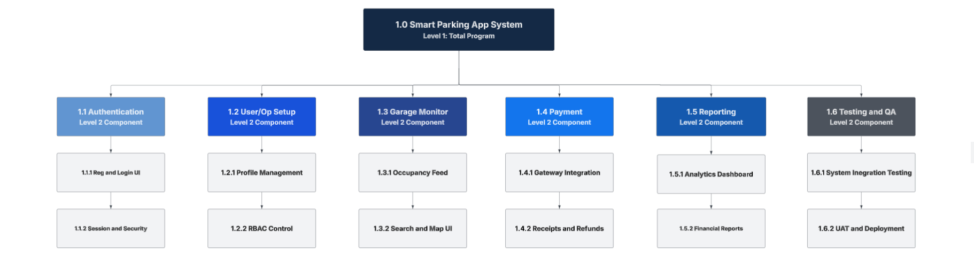
Figure 1: 3-Level Work Breakdown Structure (WBS) for the Smart Parking App System, depicting Level 1 (total program scope), Level 2 (six core functional components), and Level 3 (underlying tak packages).

- Smart Parking Application System
  - Authentication Module
    - User registration and Login Interface
      - Develop email and password sign-up forms
      - Implement multi-factor authentication (MFA)
    - Session and Security Management
      - Configure JSON Web Token (JWT) session persistence
      - Implement password recovery and reset workflows
  - User and Operator Setup
    - Account Profile Management
      - Create driver profile screens (vehicles, contact info)
      - Create garage operator profile screens (business setup)
    - Role-Based Access Control (RBAC)
      - Define admin, operator, and customer permission tiers
      - Configure backend database authorization
  - Garage Monitoring
    - Space Availability and Occupancy Tracking
      - Integrate real-time garage sensor/gate data feed
      - Build live occupancy dashboard for operators
    - Garage Search and Navigation UI
      - Implement interactive map view for finding nearby garages
      - Display real-time spot availability and pricing to users
  - Payment Processing
    - Gateway Integration
      - Connect payment gateway API (e.g., Stripe/PayPal)
      - Implement secure credit card and digital wallet processing
    - Transaction Management
      - Generate digital payment receipts and order histories
      - Build automated refund and dispute handling workflows
  - Reporting and Analytics
    - Data Visualization
      - Build occupancy trends and peak hour graphs
      - Generate revenue and daily transaction metrics
    - Data Export Engine
      - Build CSV and PDF export functionality for financial audits
      - Implement automated weakly email report scheduling
  - Testing and Deployment
    - Quality Assurance and Testing
      - Execute unit and integration testing protocols
      - Conduct user acceptance testing (UAT) and bug tracking
    - Release Management and Deployment
      - Configure production cloud environments and CI/CD pipelines
      - Perform final system launch and deployment verification

8.2 Project Timeline and Gantt Chart
Scheduling translates the WBS work packages into a chronological roadmap, identifying task dependencies, estimated durations, and critical milestones (Project Management Institute, 2021).

Project Schedule Matrix
Table 8.1: Project Schedule Matrix outlining core task IDs, descriptions, logical predecessors, estimated durations, and timeline milestones across an 11-week development lifecycle.
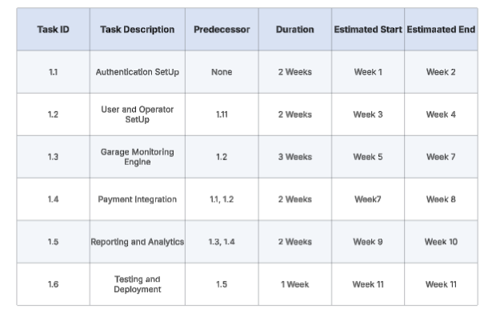

Gantt Chart
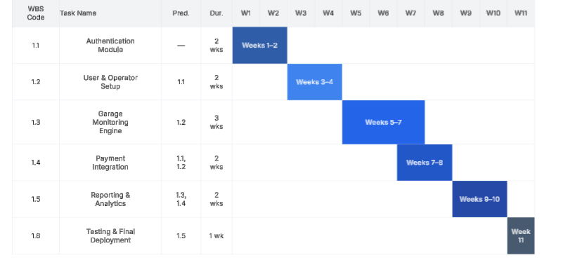
Figure 2: Visual Gantt Chart illustrating the chronological rollout, task dependencies, and overlapping schedules for the smart parking application modules from Week 1 through Week 11.

Agile Scrum Implementation and Product Backlog
Implementing modern software applications requires an interactive framework to manage changing requirements, track development tasks, and maintain clear visibility across the team. While traditional predictive models like the waterfall method rely on rigid sequential phases, agile methodologies prioritize adaptive planning, continuous development, and frequent delivery of functional increments (Reddy, 2015).
Scrum operates through fixed-length iterations called sprints, structured product backlogs, and defined ceremonies, which directly align with the sprint-based delivery requirements of the project (Schwaber & Sutherland, 2020). Kanban, by contrast, focuses on continuous flow and work-in-progress limits rather than time-boxed releases (Reddy, 2015). Utilizing Scrum ensures that the parking application’s features are methodically organized, prioritized, and built across incremental release cycles (Rubin, 2013).

Product Backlog
To establish the development roadmap, the product backlog is divided into four functional categories: Login, User and Operator UI, Backend Processes, and Reporting. Each item represents a discrete user story or task identifier consisting of a prefix indicating the category (US-L for Login, US-U for User/Operator UI, US-B for Backend Processes, and US-R for Reporting) followed by a sequential task number.

Login Module Backlog Items
- US-L01: Implement secure ser email and password registration form with frontend validation.
- US-L02: Develop backend login authentication API endpoint to verify user credentials.
- US-L03: Configure JSON Web Token (JWT) session generation and secure token persistence.
- US-L04: Build password recovery and secure reset workflow via automated email links.
- US-L05-: Integrate multi-factor authentication (MFA) verification step for enhanced account security.
- US-L06: Implement account lockout and rate-limiting protocols after consecutive failed attempts.
- US-L07: Design and build a unified logout function to terminate active sessions and clear local tokens securely.

User and Operator UI Backlog
- US-U01: Create customer dashboard home screen featuring active reservations and quick action buttons.
- US-U02: Build interactive garage search map interface with custom pins and radius filtering.
- US-U03: Design detailed garage view screen showing live spot availability and hourly pricing rates.
- US-U04: Develop vehicle profile management screen for adding, editing, and deleting registered user cars.
- US-U05: Create payment method management screen for securely saving credit cards or digital wallets.
- US-U06: Build reservation checkout and confirmation review screen with summary pricing details.
- US-U07: Develop active parking session timer and time-extension screen for ongoing reservations.
- US-U08: Build user reservation history and past receipt viewing interface.
- US-U09: Create user notification settings screen for managing push alerts and text confirmations.
- US-U10: Build operator dashboard home screen displaying real-time facility occupancy metrics.
- US-U11: Design operator facility management view for updating parking stall counts and operating hours.
- US-U12: Develop operator dynamic pricing configuration interface for setting peak-hour rate rules.
- US-U13: Build operator manual gate override console for handling visitor exceptions and overrides.
- US-U14: Create operator scan verification screen for validating digital QR codes at entry gates.
- US-U15: Design customer support and help center contact interface within the mobile application.
- US-U16: Build user profile settings screen for updating personal contact information and passwords.
- US-U17: Develop operator staff management screen for adding or removing assistant operators.

Backend Processes Backlog
- US-B01: Set up core database schema and relational tables for users, operators, and vehicles.
- US-B02: Implement backend RESTful API endpoints for user registration, authentication, and token validation.
- US-B03: Develop authorization middleware enforcing Role-Based Access Control (RBAC) separating customer and operator endpoints.
- US-B04: Build backend reservation management service to handle creating, modifications, and cancellation logic.
- US-B05: Implement automated five-minute temporary spot holding logic during checkout to prevent double-booking.
- US-B06: Integrate third-party payment gateway API (such as Stripe) for secure tokenized card processing.
- US-B07: Develop webhook handler for asynchronous payment success, failure, and refund notifications.
- US-B08: Build real-time occupancy synchronization service to update available spot counts instantly.
- US-B09: Implement WebSocket server architecture to push live inventory and occupancy updates to client screens.
- US-B10: Develop Automated License Plate Recognition (ALPR) image processing verification backend service.
- US-B11: Build gate control API integration to trigger physical barrier relays upon successful validation.
- US-B12: Implement geofencing trigger service to detect when a vehicle approaches within 50 meters of the garage.
- US-B13: Build exception-handling backend routine for unverified license plate scans and QR code fallback validation.
- US-B14: Develop automated email notification service for booking confirmations, receipts, and reset links.
- US-B15: Implement encrypted data-at-rest storage configuration using AES-256 for sensitive profile details.
- US-B16: Build secure audit logging microservice to record administrative actions and security events.
- US-B17: Implement automated database backup and retention scripts for transaction and audit logs.

Reporting Backlog
- US-R01: Build customer monthly expenditure and transaction history report generator.
- US-R02: Develop customer parking duration and frequency analytics summary view.
- US-R03: Create operator daily and weekly revenue generation reporting dashboard.
- US-R04: Build operator peak-hours occupancy utilization trend graph and heat map.
- US-R05: Implement operator turnover rate and average stay duration metric calculator.
- US-R06: Develop operator financial audit report export functionality in CSV format.
- US-R07: Build operator automated weekly email report scheduling service.
- US-R08: Create operator failed entry and LPR scan exception frequency report.
- US-R09: Develop operator payment dispute and refund tracking summary report.
- US-R10: Build operator active user growth and retention analytics dashboard.
- US-R11: Create operator promotional discount code usage and redemption tracking report.
- US-R12: Develop system performance and API response latency audit reporting view for administrators.

Sprint 1 Planning
The initial development iteration (Sprint 1) spans a standard two-week cycle focused entirely on establishing foundational security, core login capabilities, and database connectivity. The selected backlog items for Sprint 1 include:
- US-L01: Implement secure user email and password registration form.
- US-L02: Develop backend login authentication API endpoint.
- US-L03: Configure JSON Web Token (JWT) session persistence.
- US-B01: Set up core database schema and relational tables.
- US-B02: Implement backend RESTful API endpoints for authentication.
- US-U01: Create customer dashboard home screen wireframe and UI layout.

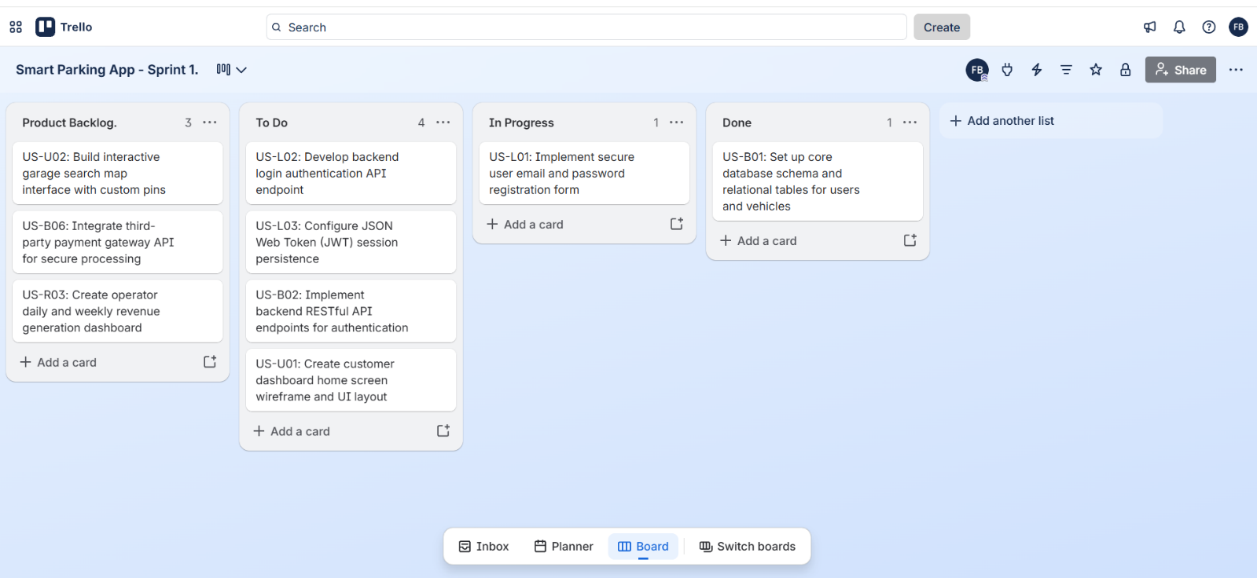
Sprint 1 Trello Board Configuration
Figure 3: Illustrates the configured Trello board for Sprint 1, displaying the product backlog, active sprint commitments across the workflow columns, and completed foundational tasks.
3

Risk Management and Communication Plan
Managing uncertainty and maintaining transparent communication are critical for ensuring that software development projects meet their delivery milestones without compromising system reliability (Kerzner, 2022). For the smart parking application, proactive risk management and structured communication cadences prevent unexpected disruptions across technical integration, schedule execution, financial budgeting and human resource allocation.
The risk identifiers utilize standardized categorical prefixes followed by sequential numbering. Specifically for Technical Risks (TR), Schedule Risks (SR), Financial Risks (FR), and People Risks (PR), to ensure clear traceability across the project risk register.

10.1 Risk Identification Across Categories
To establish a robust risk management baseline, potential threats have been identified across four primary dimensions, with seven distinct risks documented per category:
- Technical Risks:
  - TR-01: Integration failures when connecting third-party payment gateway API (such as Strip) with custom backend transaction handlers.
  - TR-02: Latency spikes or websocket during real-time parking occupancy updates across high-traffic garage locations.
  - TR-03: Data synchronization errors between Automated License Plate Recognition (ALPR) image processing outputs and physical gate control relays.
  - TR-04: Security vulnerabilities or token expiration failures within JSON Web Token (JWT) session persistence configurations.
  - TR-05: Unhandled exceptions or data loss during asynchronous webhook callbacks for payment success and failure notifications.
  - TR-06: Database connection pool exhaustion caused by excessive concurrent RESTful API query requests from mobile clients.
  - TR07: Encryption implementation flaws or key management failures when sorting sensitive profile details using AES-256 data-at-rest configurations.
- Schedule Risks
  - SR-01: Scope creep during Sprint 1 or subsequent iterations due to expanding user interface wireframe requirements.
  - SR-02: Delays in completing foundational database schemas (US-B01) that bottleneck dependent backend and reporting API developments.
  - SR-03: Bottlenecks caused by unexpected debugging time required for multi-factor authentication (MFA) and account lockout protocols.
  - SR-04: Extended code review and testing cycles delaying scheduled release increments from transitioning into the production environment.
  - SR-05: Additional time required to resolve unexpected cross-browser compatibility issues in customer and operator dashboard layouts.
  - SR-06: Unforeseen delays in securing third-party sandbox API keys and credentials for payment and geofencing integrations.
  - SR-07: Development velocity slowdowns resulting from complex debugging procedures associated with real-time websocket synchronization logic.
- Financial Risks
  - FR-01: Cost overruns associated with exceeding free-tier limits on cloud infrastructure and database hosting services during peak testing phases.
  - FR-02: Unexpected transaction processing fees or merchant chargeback liabilities incurred during third-party payment gateway integration.
  - FR-03: Budget reallocation required to license specialized enterprise software components for automated license plate recognition hardware.
  - FR-04: Financial losses resulting from delayed billing deployments pushing back revenue-generating operator reporting dashboards.
  - FR-05: Increased operational expenses due to higher-than-expected cloud data transfer rate for live video and processing stream.
  - FR-06: Costs associated with purchasing supplementary SSL certificates and enterprise security tools for production environments hardening.
  - FR-07: Potential financial penalties or compliance audit expenses resulting from inadequate data privacy or token storage protocols.
- People Risks
  - PR-01: Knowledge silos occurring when critical backend authentication and database architecture details are understood by only one developer.
  - PR-02: Productivity decreases resulting from steep learning curves associated with configured unfamiliar cloud infrastructure or web sockets.
  - PR-03: Communication friction or misalignment regarding sprint backlog priorities and task assignments.
  - PR-04: Resource constraints or unexpected availability conflicts impacting developments pacing during critical sprint windows.
  - PR-05: Burnout or fatigue caused by heavy workloads during final integration and testing phases of the sprint cycle.
  - PR-06: Skill gaps in advanced automated testing methodologies leading to insufficient unit and integration test coverage.
  - PR-07: Miscommunication regarding interface design specifications leading to rework on frontend wireframes and component layout.
10.2 Comprehensive Risk Register
The risk register systematically logs identified threats, assigns probability and impact metrics, defines ownership, and establishes concrete strategies across 13 detailed entries (Kerzner, 2022; Project Management Institute, 2021).

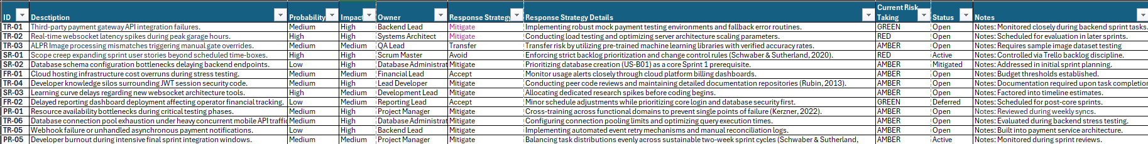
Project Risk Register and Mitigation Strategies
Table 10.1: Summary of identified technical, schedule, financial, and people risks, including associated probabilities, impacts, ownership, response strategies, and current tracking status.
10.3 Communication Plan
Effective communication ensures that project status, risks, and technical adjustments are transparently shared across all stakeholders and functional teams (Project Management Institute, 2021).
- Meeting Cadence:
  - Daily Standups: 15-minute syncs to review daily progress, discuss immediate blockers, and align task execution the active sprint board (Schwaber & Sutherland, 2020).
  - Sprint Planning and Review: Bi-weekly sessions held at the start and end of each two-week sprint cycle to evaluate complete deliverables, inspect the product backlog, and plan subsequent iterations (Rubin, 2013).
  - Stakeholder Progress Briefings: Monthly scheduled updates detailing major milestones, risk register adjustments, and high-level financial or schedule statuses.
- Reporting Methods and Channels:
  - Task Boards: Trello serves as the primary visual channel for real-time task tracing, workflow movement, and status transparency across product backlog, to-do, in-progress, and done columns.
  - Documentation Repositories: Centralized cloud storage used for maintaining architectural diagrams, API documentation, meeting minutes, and risk register updates.
  - Asynchronous Messaging and Email: Utilized for rapid day-to-day technical inquires, urgent blocker alerts, and formal milestone notifications.

References
Kerzner, H. (2022). Project Management - A Systems Approach to Planning, Scheduling, and Controlling (13th Edition) (Thirteenth edition). John Wiley & Sons.
Org charts : Lucidchart. (n.d.). https://lucid.app/lucidchart/41130623-76db-4ade-a44f-563cd3c6e816/edit?beaconFlowId=0D68B0049A90986C&invitationId=inv_7eb96148-6cd2-4619-9993-50377cb7c3c1&page=0_0#
Project Management Institute. (2021). The standard for project management and a guide to the project management body of knowledge (PMBOK guide). Project Management Institute.
Reddy, A. (2015). The Scrumban [R]Evolution: : Getting the Most Out of Agile, Scrum, and Lean Kanban (1st edition). Addison-Wesley Professional.
Rubin, K. S. (2013). Essential Scrum : a practical guide to the most popular agile process (1st edition). Pearson ITP.
Schwaber, K. and Sutherland, J. (2020) The Scrum Guide: The Definitive Guide to Scrum: The Rules of the Game. Scrum.org & Scrum Inc. https://www.scrumguides.org/scrum-guide.html

